# ATTENTION!!

Guys, ganto.. Kailangan na nating maipasa yung Business Requirements natin sa per module. (DAPAT MARAMIAT DETAILED). Tas mga ¼ nun ay malagyan na ng functional requirements. Ano ang pinagkaiba nila? Ganto.. Ang sa business requirements, dun ilalagay yung mga bagay ng nagagawa ng mga user. It goes like, “the user can.. The user must.. The user shall” ganun tapos sa functional naman na ay kung pano magrereact yung system dun sa gagawin ng user like: “the system will, the system shall, the system must etc.” ganun. Bale, per module pa rin yun. 7 na modules natin wala pa yung sa site configuration tayo nalang yun lahat. Tig isa nalang tayo dun.

1 Citizen’s Info -Lowell

2 Business’s Info -Jash Remmel or Peter

3 Ordinances -Jeremiah

4 Blotter -Remmel Jash

5 Issuance -Remmel Jash

6 Summons -Peter

7 Project Monitoring -Carlo

Kung may mga ideas kayo sa mga ibang module na hindi naassign sa inyo, y’all can add at isulat niyo na rin. Sino may net? Send ko yung docu na ginagawa ko sa onedrive. Para live edit jk hahahahaha XD kaya natin to guys hahaha PAG WALA KAYO GAWA BUKAS NAKOOO!

Here’s the agreement:

Bale parang may 4 interface tayo sa system. Isang para sa admin side, isa treasurer, secretary na para nasakanila yung medyo full access isa sa brgy captain side tas isa sa typical user. Ganto..

ang sa Admin side ay yung mga sa type ng Positions, Official’s List, then sa user’s list.

Sa secretary treas side, sila ang may hawa ng most ng modules. Citizen Profiles, Business, ordinances, blotter(PERO WALANG SOLVE kasi si captain lang ang may karapatang magsolve ng kaso), Summons, issuance, Project monitoring.

Ang sa Brgy captain ay sa dashboard ng system tapos yung sa approval ng blotter

Tas sa typical na user ay pwede lang magadd ng blotter kasi sabi ni Jash pwede kahit sino magadd ng ipapablotter.

Sooo, ayun.. Godspeed! :D

sp_help tablename

Reports:

1. List of Residents
2. List of Officials
3. List of Summons
4. List of Ordinances
5. List of Blotters
6. List of Businesses

# CITIZENS (Profiling) Lowell

Citizen’s Info’s Table to be displayed

1. NAME (Salutation, First Name, Middle Name, Last Name, Name Extension (Jr, Sr, III, etc) )
2. Place of birth
3. Birthdate
4. Nationality
5. Residence Status (Active/Inactive)
6. Civil Status
7. Gender
8. Zone (Sitio)
9. Street/Block
10. Date and time recorded
11. ACTIONS (Edit a profile)

Citizen’s Info Required (Citizen’s Form)

1. Salutation
2. First Name
3. Middle Name
4. Last Name
5. Name Extension
6. Height (Ft)
7. Weight (kg)
8. Place of birth
9. Birthdate
10. Nationality
11. Residence Status
12. Civil Status
13. Occupation
14. Gender
15. Blood Type
16. House Number
17. Street/Block
18. Zone (Sitio)
19. Person to contact in case of emergencies
20. Contact Number

EDIT TERM

1. Position
2. From – To

If Barangay Official

1. Is a barangay official (Yes or No)
2. Position
3. Office Term (Date from to)

If USER

1. User? (Yes or No)
2. User Type
3. User Name
4. Password
5. Secret Question
6. Answer

## Position

1. Positions Available
2. Description
3. Status (Active or Inactive)
4. ACTIONS
   1. Edit the status and Description
5. Can Create New Position Form
   1. Position name
   2. Description (Optional)
   3. Status

## Official’s List

1. Official Position
2. Full Name
3. Birthdate
4. Gender
5. Street
6. Sitio
7. ACTIONS
   1. Edit Profile ng Citizen

## USER

1. User Type
2. User Name
3. Full Name
4. Birthdate
5. Gender
6. Street
7. Zone/Sitio
8. ACTIONS
   1. Edit

# BUSINESSES Jash, Remm or PJ

(To be displayed)

1. Business name
2. Location
3. Manager/Owner
4. Address
5. Date Issued
6. Status (Validity
7. ACTIONS
   1. Edit

Business Form to be added

* 1. Business Name
  2. Location
  3. Manager
  4. Address
  5. Status

# Ordinances Jeh

(To be displayed in the table)

1. Ordinance Number
2. Ordinance Title
3. Category
4. Authors
5. Date Implemented
6. Status
7. ACTIONS
   1. Edit
   2. Disable
   3. Report

Ordinance Form to be added:

1. Ordinance Number
2. Ordinance Title
3. Ordinance Category
4. Authors
5. Description
6. Sanction
7. Date Implemented
8. Status

# Blotter Data (Barangay Blotter) Jash & Remm

(To be displayed sa table)

1. Blotter No
2. Date of Incident
3. Complainant
4. Accused
5. Subject
6. Status
7. Resolution
8. Date Recorded
9. ACTIONS
   1. Edit
   2. Disable (Case Solved)
   3. Report Print

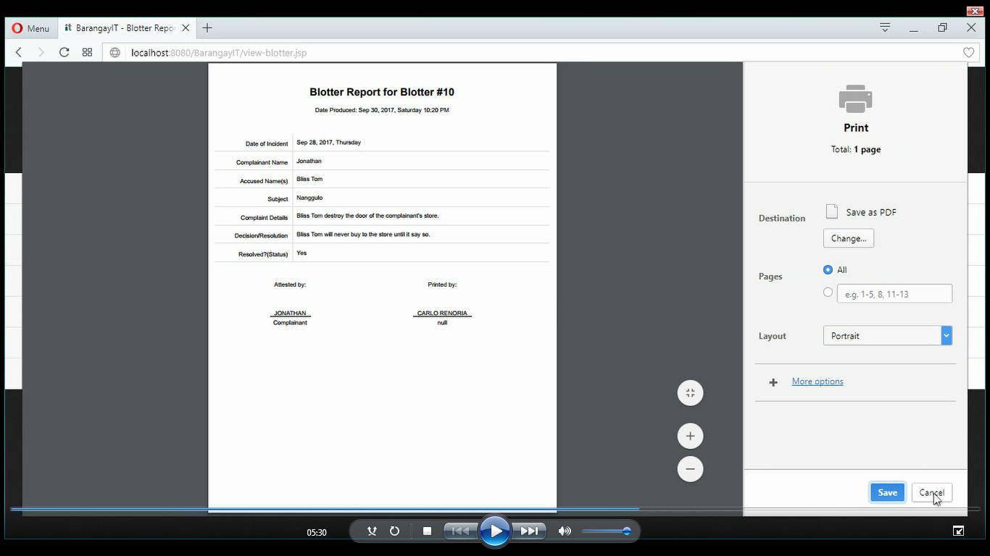

Blotter Form (Maga-add)

1. Date of incident
2. Complainant
3. Accused
4. Complain Statement
5. Blotter type
6. Decision
7. Status ()

# Summons PJ

1. Blotter No
2. Date of incident
3. Complainant’s Name
4. Name of the Accused
5. Case
6. Schedule
7. Status
8. Action Taken
9. Date and Time Recorded
10. ACTIONS
    1. View Patawag Report
    2. Edit
    3. Resolve

Summon Forms

1. Blotter No.
2. Schedule

Date, Time, Place

# Issuance Jash & Remm

1. Full Name
2. Place of birth
3. Birthdate
4. Nationality
5. Civil Status
6. Gender
7. Street
8. Sitio
9. Date/Time Recorded
10. Actions
    1. Certify Report

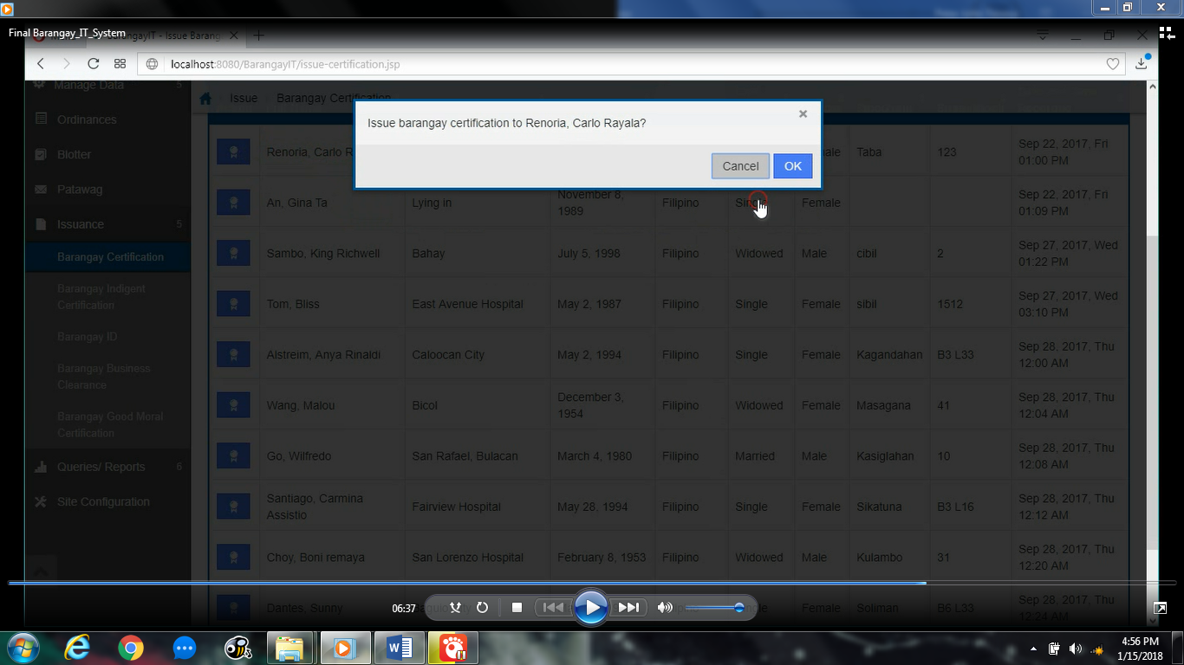

Barangay Certification SideNav

* + 1. Barangay Indigency
    2. Barangay ID
    3. Business Clearance
    4. Certificate of Good Moral
    5. ETC!!!!!

# Project Monitoring Carlo

1. Project Name
2. Project Location
3. Project Description
4. Number of Phases
5. Date Starts of the First phase
6. Date Finishes
7. People Involved (Brgy Officials)
8. Status
9. ACTIONS
   1. Edit

# SITE CONFIG (Barangay Details) LAHAT!!

Config Settings

1. Province Name
2. City/Municipality
3. Independent/Component
4. Barangay Name
5. Signatory (Chairman??)
6. Municipal Seal
7. Barangay Seal
8. 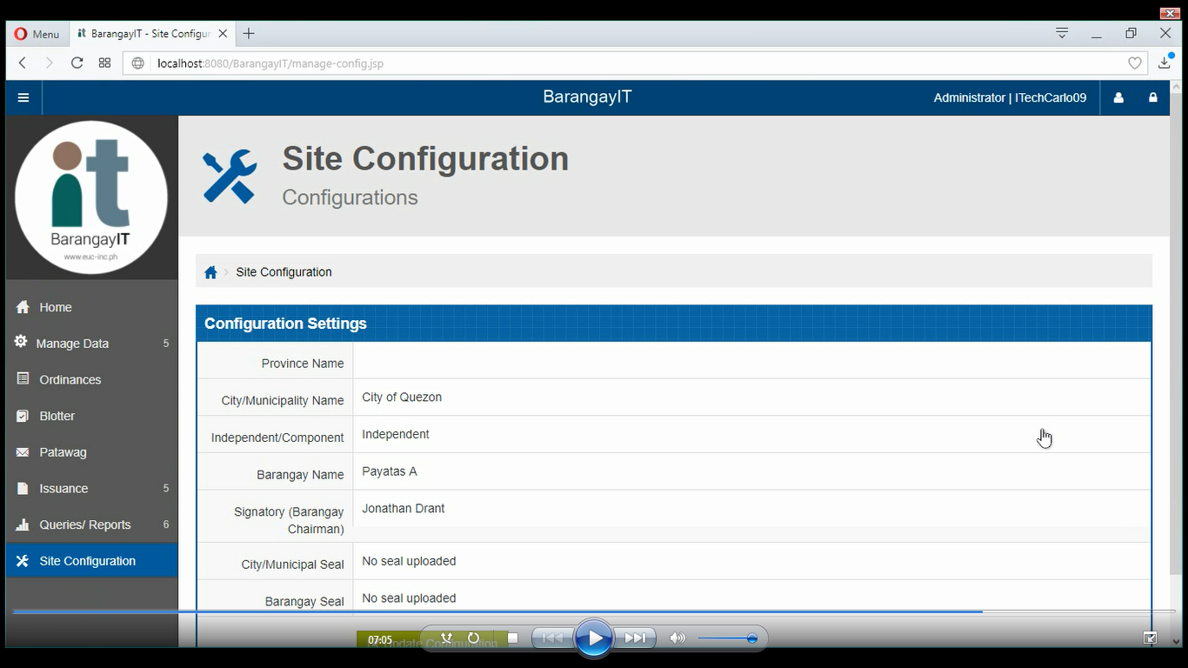
9. UPDATE CONFIG

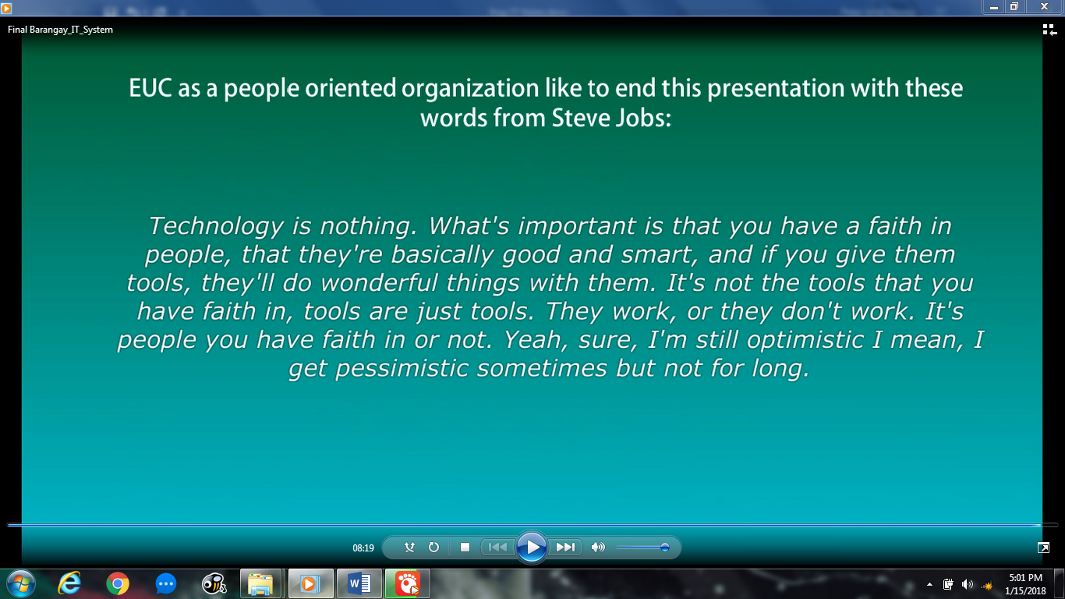

# REQS NA CERTS

